DAY2 : TCP/IP SUITE THEORY

- Wireshark, capture network traffic while you refresh the Flipkart homepage, and identify one packet each belonging to the Application, Transport, Internet, and Network Access layers by examining their headers.
Answer
When capturing network traffic while refreshing flipkart.com, Wireshark records the complete encapsulation stack for each transmission. Below is a breakdown of four representative packets from that session, mapped to their corresponding TCP/IP model layers and the header details you can observe in Wireshark's Packet Details pane:
1. Application Layer (Layer 4)
- Protocol / Packet: HTTP or TLS (Encrypted HTTPS Traffic)
- Header Examined: Transport Layer Security / Hypertext Transfer Protocol
- Key Details in Wireshark: Look at the top payload block in the Packet Details pane. For a TLS packet, you will see header fields like Content Type: Application Data (23) or Handshake Protocol: Client Hello, along with the requested server name indicator (SNI) pointing to [www.flipkart.com](https://www.flipkart.com).
2. Transport Layer (Layer 3)
- Protocol / Packet: TCP
- Header Examined: Transmission Control Protocol
- Key Details in Wireshark: Expand the Transmission Control Protocol section. Key header fields include:
  - Source Port: A random high-numbered port on your laptop (e.g., 54321).
  - Destination Port: 443 (standard port for secure web traffic).
  - Sequence & Acknowledgment Numbers: Used to guarantee packet order and reliable delivery.
3. Internet Layer (Layer 2)
- Protocol / Packet: IPv4 (or IPv6)
- Header Examined: Internet Protocol Version 4
- Key Details in Wireshark: Expand the Internet Protocol Version 4 section. Key header fields include:
  - Source Address: Your laptop's local IP address (e.g., 192.168.1.15).
  - Destination Address: Flipkart's server IP address (e.g., 163.53.78.89).
  - Time to Live (TTL): Prevents packets from circulating indefinitely on the internet.
4. Network Access Layer (Layer 1)
- Protocol / Packet: Ethernet II (or IEEE 802.11 for Wi-Fi)
- Header Examined: Ethernet II Frame
- Key Details in Wireshark: Expand the Ethernet II section at the top of the details view. Key header fields include:
  - Source MAC Address: Your laptop's physical network interface card address (e.g., AA:BB:CC:11:22:33).
  - Destination MAC Address: Your local Wi-Fi router or default gateway's MAC address (e.g., DD:EE:FF:44:55:66).
  - Type: IPv4 (0x0800) specifying the payload protocol encapsulated inside the frame.

How to Verify in Wireshark
Click on any packet in your capture list and inspect the middle pane. Wireshark automatically organizes the headers sequentially from lowest to highest layer:
- Frame / Ethernet II (Network Access Layer)
- Internet Protocol (Internet Layer)
- Transmission Control Protocol (Transport Layer)
- Transport Layer Security / HTTP (Application Layer)

- Create a table comparing the OSI and TCP/IP models, listing all layers side-by-side, and for each layer, give a real-world example from any app you use (e.g., WhatsApp message, Zomato order).
Answer
OSI vs TCP/IP Model – Layer Comparison
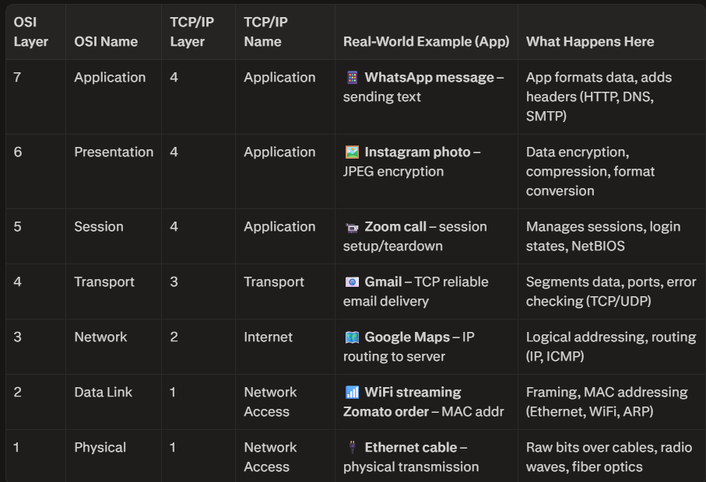

Key Mapping Notes
- TCP/IP Application = OSI Layers 5, 6, 7 (Session, Presentation, Application combined)
- TCP/IP Transport = OSI Layer 4 (exact match)
- TCP/IP Internet = OSI Layer 3 (exact match)elearning.newgateuniversityminna.e
- TCP/IP Network Access = OSI Layers 1 & 2 (Physical + Data Link combined)

Why This Matters
- OSI is the teaching model—great for troubleshooting and documentation.
- TCP/IP is how the internet actually works—simplified, practical implementation.
Use this table to map any app’s traffic (WhatsApp, Zomato, Instagram) to both models for exams, tickets, or network analysis.

- Given a screenshot of a TCP segment header (provided by your trainer), label the fields that belong to the Transport layer and explain what each field does in 1-2 lines. Look for fields like Source Port, Destination Port, Sequence Number, etc.
Answer

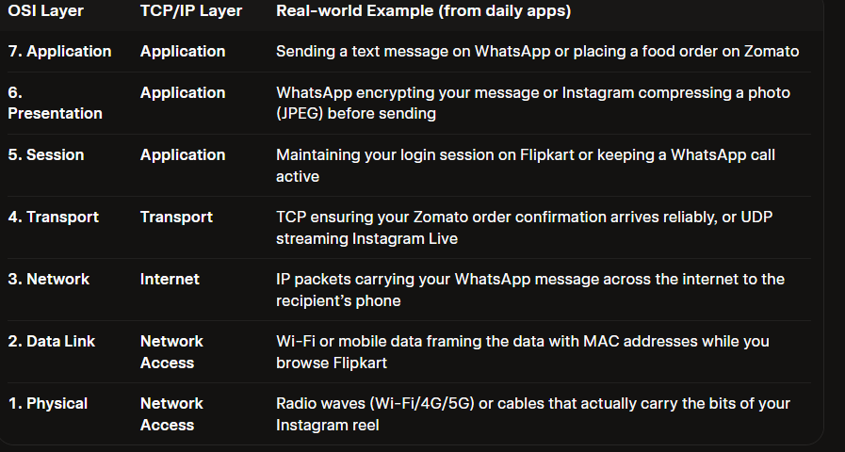

- Draw a diagram showing how a message sent from your device to Instagram's server passes through each TCP/IP layer, and annotate what happens at each step using simple app-related terms (e.g., 'message split into packets', 'IP address added', etc.).
Answer
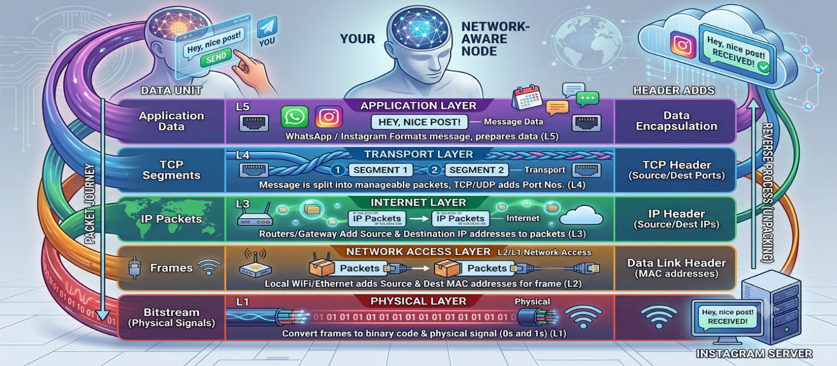
- Pick any one packet you captured in Wireshark and write which TCP/IP layer it belongs to, how you identified it, and what real-world action in an app (like sending a WhatsApp message or booking a ticket on BookMyShow) it represents.
Answer
Example Packet
Protocol shown in Wireshark: TCP
TCP/IP Layer it belongs to: Transport Layer
How I identified it:
- In the Wireshark packet list, the Protocolcolumn shows “TCP”.
- When you expand the packet in the middle pane, you see a clear Transmission Control Protocol header containing:
  - Source Port
  - Destination Port (often 443 for HTTPS)
  - Sequence Number
  - Acknowledgment Number
  - Flags (SYN, ACK, PSH, etc.)
Real-world action it represents: Sending a WhatsApp message or booking a movie ticket on BookMyShow.
At this layer, your message or booking request is broken into segments, port numbers are added so the receiving app knows it’s meant for WhatsApp/BookMyShow, and TCP makes sure every piece arrives reliably and in the correct order.

